**NORTH WEST REGIONAL COLLEGE**

**DEPARTMENT OF SCIENCE TECHNOLOGY AND CREATIVE INDUSTRIES**

**WORK BASED LEARNING - WEEKLY REPORT**

**NAME:** Sean Carlin

**REPORT NO:** 5 **DATE:** 03/04/2020

Please use the space below to give details of your activities for this report period. Your outline should include - in as much detail as possible, **a breakdown of activity by project**. You should aim to address areas such as perceived organisational benefits, desired outcomes and deliverables.

For each project that you are working on – you should indicate the title, progress, targets met and expected completion date.

**Summary of activities:**

Not a lot of progress this week as my only task was to research the ‘PLU Links’ for the products within the Vectron systems, PLU links are basically options that are attached to specific products, for example, the user selects a Steak, and then the PLU link would give the user another option for how they want the steak done, e.g. well done and so on. As you can see below:

However, having the PLU links enabled caused issues with my solution as it stopped it being entered automatically since it needed a further option selected. I had some trouble trying to fix this as I couldn’t find the fault through my code. I had to diagnose the fault by commenting out lines of code individually to see what worked and what didn’t. Eventually I fixed this by disabling it, I disabled this by adding an extra piece of code to a method. After this the solution runs fine.

After some error handling I worked on the *complexity* of my program, this means I altered and cut down some unneeded code that I then *‘encapsulated’* into methods that can be written once but used many times.

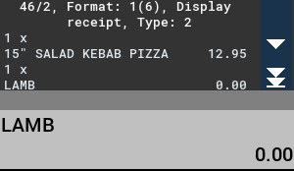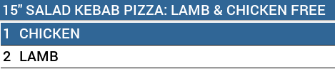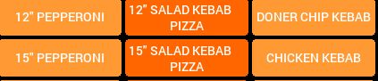

**Comments on progress:**

This week I had minimal progress due to having an issue by disabling the ‘PLU Links’ as mentioned above. However, after a short call with my mentor, Theo Huenestein, I recognised the issue, and had it resolved.

**Planned tasks:**

* Need to encapsulate more methods
* Improve complexity